Spring BOOT Micro service - Level 1 Communication

- fundamental idea is that building application in different way

- not a traditional monolithic way like single application Ex:deployed single entity

-Deployed in servers and scales as one entity

- We can Multiple module project at the end if deply in same server it become monolthic application only

- Micro service that changes we can still follow same pattern of coding but whats deployed n wts happeing in runtime its differnent.

Agenda

-Creating Microservice

-Communicate with each other

Where Do u start?

1 lots of technologies

- lot of ways to start, Spring Cloud is one set of technology fr creating microservice many more

2 lots of pattern

- additional to technology we have lot of pattern each of thechnology have patterens need to be followed

3 Interdependent consepts

- biggest challenge is they are interdepdent how to break it

4 why?

- one monolotic app breaked into bunch of problms

- solving scalbilty and modularity of depolyment

-make changes to one small portion of app with out distutbing whole thing

- bcz of modularity u have to make sure relase process is fine bcz we have scalabilty so need to amke sure our microservice is scalable can have multiple copies

And still have application running

- Load Balance is generic prblem

-Ex : using Eurka to handle load balance

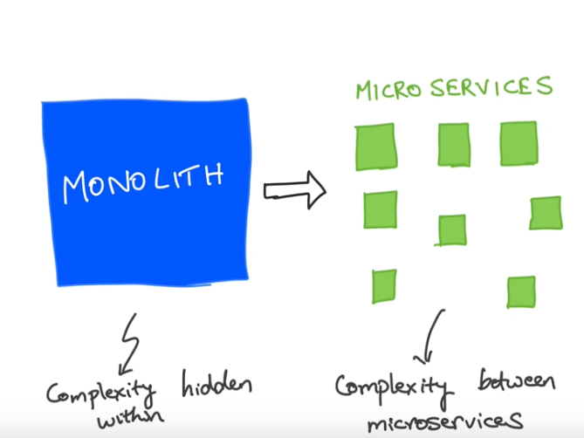

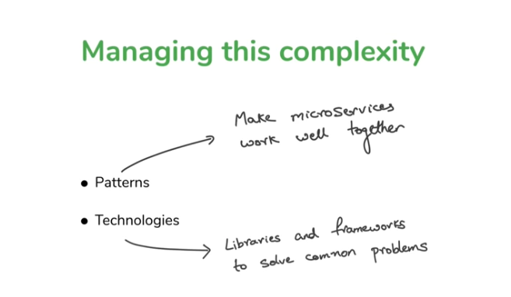

What is pattern :

When application breakdown into different service how do u have them communicated each other how do u have the discover whom to communitcate with

- So identifying it is the server discovery

- Service Discovery is pattern

- WE have technoglies whic allow fr tat pattern Ex: Eureka

100 developers working on Microservice run into same prblm so lets create farmwork which help those 100 developers thats what eurka created

- Which resolver the problem Server discovery

Diff B./W Micro and Web Service

- Service Oriented A/c is enterprise way of building app

- both shares common philosphy but idea is the what the objective of A/cis

-when buuiding Service oriented A/c your building service for reusabilty and you dnt have idea it is going to be used

- Ex Ip locater SErvice is a service built in service oriented a/c its service built in service oriented A/c it has as endpoints using SOAP make call on given IP then it shows location

- When this kind of service created they dnt have a[plication in mind they made has utility service

- lot service orietned concepts are around creating utility dnt where its gone be used so let creat and keep it and any body can use it

- but Micro service is not like that here u have idea about that that appliation breaking applciation into microservice we know where and how use full it is for your applciation

- Service oriented has lot of complexity bcz they wanted to scale like some features be used some where and wanted to make standradize wanted to have explicit confront. Service bus to handle to service

- Service in Service Oriented A/c deal only with data not Ui . How abt in Micro service?

- UI will be another micro service - Microservice which consume other microservice

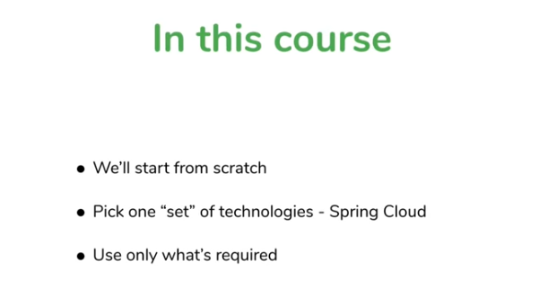

- From Scratch

- Technology will be spring Cloud for building a robust application

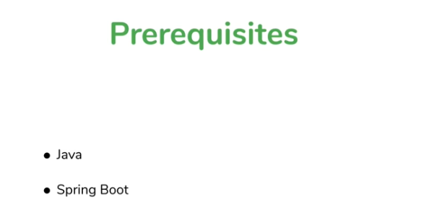

This are prereuisites

- Each micro service is Seprate Spring Boot Application

Spring Micro Scrive Creation

Ex : 1 Good Reads: a website for catlog off book and its rating

Simlar we do for Movie Catlalog with movie details and its rating

MovieCatalog

3 microservice will be created 1 micro service provide some data another microservice provide another data 3rd microservice call this 2 data consoldiate in sends response

MOVIE CATALOG API APPLICATION

Imagine a java script API developer who need follwing data

Front End View

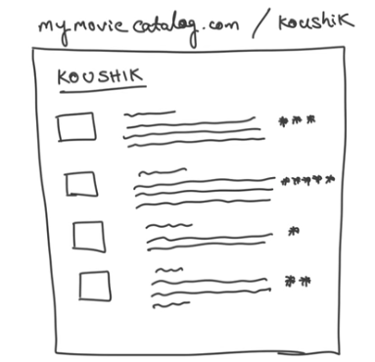

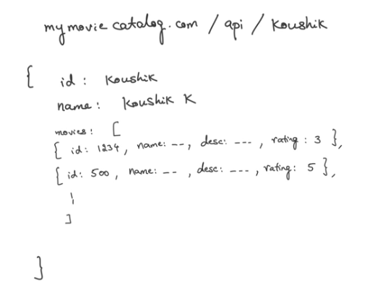

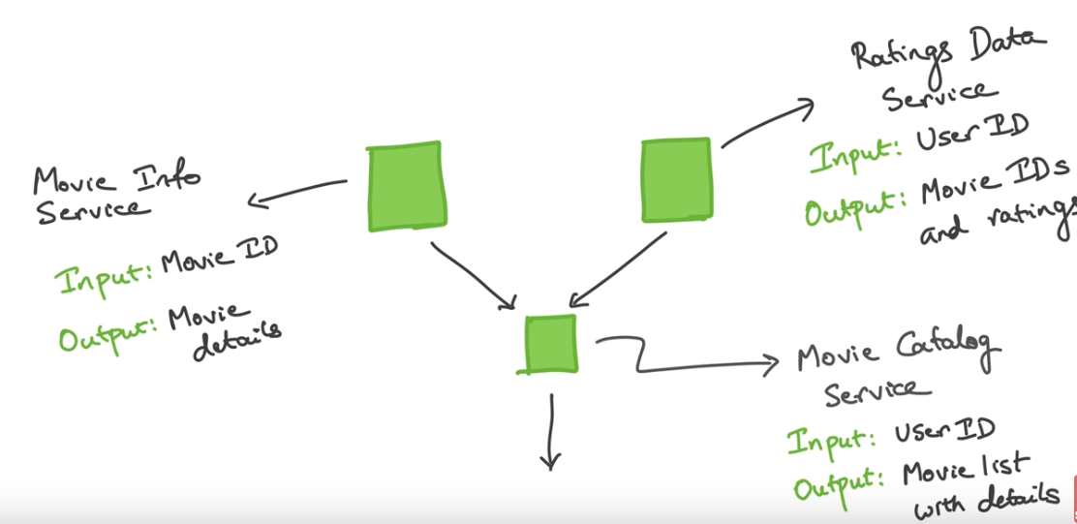

1 Movie catlalog service is called based on UserId

2 Based on UserID which ever the user matched movies and rating given by him taken

3 Based on that rating and movie Id Movie deatils will be fecthed feom Movie Info APi

4 Catalog will put together and Show response

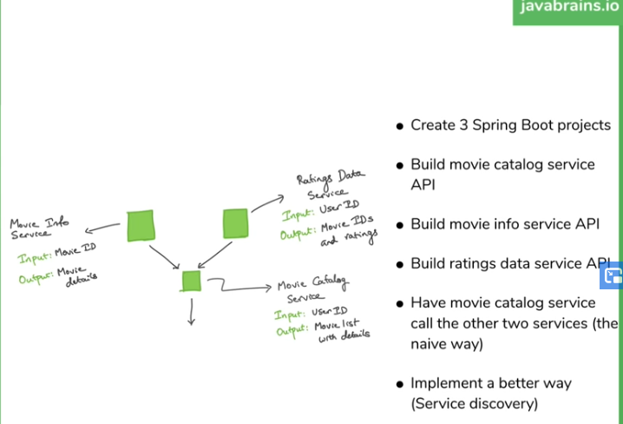

1 Create the 3 Service

- create 3 spring Boot Application

-ways of creating it A) add maven depednecy paratmeter B) spring CLI C) Spring.io intializer D)IDE

Add web has depedency

Project 1: moviecatalog

Project 2: movieinfo

Project 3: movierating

Moviecatalog: Rest API

- create RestController create and End point to provide List of CatalogItem based on userID

MovieInfo: Rest API to provide movie info based movied id from the rating given by the user id fr the user rated and wached movie

Movierating: APi provide rating of movie along with moviedID for the user who has rated fr that movie watch n rated by user

- Configer Server ports uniquly bcz two microservice communicatin each othr so server port is to be configured

- change in application.properties files ex 8081,8082,8023

- changing the port is nothing but new instance

- now 3 application ready with no relation to each other

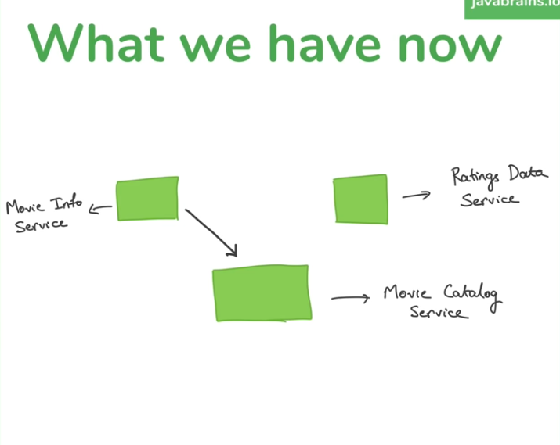

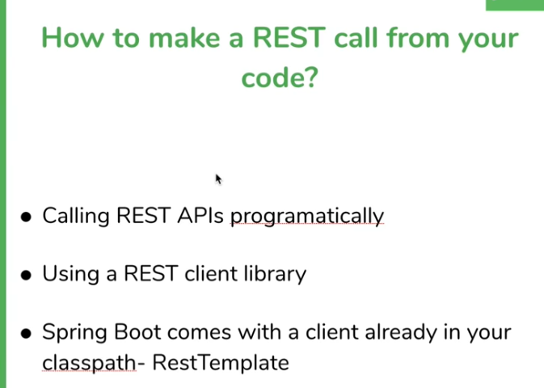

- Since it is Rest all the text tranfered over is text(Stirng) so take response unmarshal it create an object

- Spring boot come with REST client -RestTemplate which is used to make rest api calls

- RestTempalte (easy way) will be deprecated soon another way of doing this is WebClient (HardWay)

- WebClient hard way because it need Reatice programming

-Reactive Programming in java: Reative programmin is different way of doing coding in java which Is not synchronal it allows certain Asnyrhonous consturcts even though whole syntax structure and structure are around java lang is asynchornous

- differnt to work with syncrihonus way of java to asynchornos way of java

- instead of doing step by step will have call back and let m know once function ready and call itusing lamda fr ex

Copy All the models in different service into the catalog api so RestTemplate can map to object

DEvelopemt In catalog APi

1 GEt All Rated Movie ID’s

2 for each movie ID call movie info service to get details

3 put them all together

// Step 1 -> Sol-1: hard code way

List<Rating> ratings = Arrays.asList(new Rating("1234", 3), new Rating("5678", 4));

- Can do for loop or map

- for each rating I need to repalce with each rating with catalog item :

- ratings.stream().map(rating -> new CatalogItem("Sachin", "super", 5))

- then need to get that inforamtion here and return it : .collect(Collectors.toList())

// Step 2 -> Sol-1: Rating Interation and movie info hard code way

return ratings.stream().map(rating -> new CatalogItem("Sachin", "super", 5)).collect(Collectors.toList());

It has to be done through rest template communcation happens through rest template what we get will be string we need to object deal so use same class to map it using marsh it

- For each of the movie we call to movie info n get movie details

- we need to make a block in itertaion it will not be single line so adding block

- need to create RestTemplate to make calls to service get movie details

-once RestTempalte create suing method below method passing service URL and Class name need to mapped

Movie movie = restTemplate.getForObject("http://localhost:8082/movies/" + rating.getMovieId(), Movie.class);

We get String in response its also helps to unmarahsl into object if we know payload of that response we can provide the class which as same propertie as the json

Then RestTemplate create the instacne of the class populate properties to n give fully formed object

- we have same multiple copy of models in microservice but not in monolithic technicaly it is allowed in microservice

- bcz we also create a library of all model class and add it has depedncey every where and use it in all over but draw back is some one want change agian need to manage all we defeat all microservice here beign independent

-in version controll part addign new property no issues if its der in class it will map no issues but removing a property will give error that has to be informed

- No arg Constructor should be der for mapping n mandatory

- We have look after this in java when unmarshal something which is not an object to an object we need to provide empty constructor

- how marshalling / unmarahclin works works java create an instance 1st then pasrse string and populate one by one

// Step 2 -> Sol-1: Rating Interation and movie info from RestTeamplate Calling

// MovieInfo API like below code

// Movie movie = restTemplate.getForObject("localhost:8082/movies/rush",

// Movie.class);

return ratings.stream().map(rating -> {

Movie movie = restTemplate.getForObject("http://localhost:8082/movies/" + rating.getMovieId(), Movie.class);

;

return new CatalogItem(movie.getMovieId(), movie.getDesc(), rating.getRating());

}).collect(Collectors.toList());

- 1 What are wrong in above impl hard coding of URL it has to be dyanmic or discovring service ex we change port will get in trouble

- it should be wr service running pick it from der

- 2 RestTemaplate need to created once not every time so make it has been in intailization so it can autwired any wr only one time object created and used every wr

- To create a single instance on any object in spring and have it sahred across mulitple class by creating bean by defauly singleton

- using @Bean basically it used over any top of method it excecuts that method and mappes into it that Method retrun type

-any one who autowire these return type get retutn tyoe of these bean method

-@Autowire is consumer telling give me something @Bean is producer excute it and save it some wr and give if some one asks

- lazy n eager Bean also there

-@Bean can be done any where but is has be in calss path and in @Compenet class are its derived class@Bean

public RestTemplate getRestTemplate() {

return new RestTemplate();

}

@Autowired

private RestTemplate restTemplate;

- Since RestTemplate will be deprecated will WebClient aslo

- its more verbose then RestTemplate

Movie movie = restTemplate.getForObject("http://localhost:8082/movies/" + rating.getMovieId(), Movie.class);

- above live need to be repalce with WebClient

- in tratditonal web deals with step by step but in reative it deals with flux or mono objects

- its asnychrous programming

- need to give lamda when ur done excuting call this or do this operation or run this lamda

This class need to be used to this reactive web depedncy need to be added in pom.xml WebClient.Builder

/**

*

* @param userid send user id Based on that get movie info and its rating

* @return CatalogItem with merging 2 Micro services

* @see "WebClient" is used to call API and Map it to Objects

*

* <pre>

* <p> 1. Get All rated Movie ID's</p>

* <p> 2. For Each movieId ,call moive info Id service and Get Details</p>

* <p> 3. Put All togethe</p>

* Its a asynchronus fecthing loop

*

* .build() new instacne of client every time from build pattern

* get() type method we are calliin get are post r put

* .uri("http://localhost:8082/movies/" + rating.getMovieId()) provide endpoint

* .retrieve() all given now retrive data

* .bodyToMono(Movie.class) saying wt ever body u get back converted into instacne of movie class

* Mono? - its a reaactive way of saying your gettign object but not right away soem time in futur

* method itself returning list of catalog items

* since its asynchoruns so it will not wait till it is compled to wait fr all data so how to handle either method has to asynchrouns method

* r need to make web client to wait all is ready tat will be by blocking

* .block() blocking execution till mono is executed

*

* </pre>

*/

@GetMapping("/webclient/{userid}")

public List<CatalogItem> getWebClientCatalog(@PathVariable("userid") String userid) {

// Step 1 -> Sol-1: hard code way

List<Rating> ratings = Arrays.asList(new Rating("1234", 3), new Rating("5678", 4));

return ratings.stream().map(rating -> {

Movie movie = webClientBuilder.build().get().uri("http://localhost:8082/movies/" + rating.getMovieId())

.retrieve().bodyToMono(Movie.class).block();

// all above to get Movie Details from webClient

return new CatalogItem(movie.getMovieId(), movie.getDesc(), rating.getRating());

}).collect(Collectors.toList());

// commented so can test with dynamic data

// return Collections.singletonList(new CatalogItem("Sachin", "super", 5));

}

}

3 Making Call to Rating API

@GetMapping("/users/{userId}")

public List<Rating> getRatingByUserId(@PathVariable("userId") String movieId) {

return Arrays.asList(new Rating("1234", 5), new Rating("5678", 4));

}

O/p:

[

* {
  + "movieId": "1234",
  + "rating": 5

},

* {
  + "movieId": "5678",
  + "rating": 4

}

]

What is the problem with above approach

-ok not recommended problme is

- root node of this above json is List not an object

What is the problm with an Api That Return List as root node

- Deserialization is drawback

-when we contstruct an API which top level node as object want enhance object like adding field to it we can do it with out breaking the consumer

- who need it will use who dont need they will not use it

Ex in above list I want add username in object like ehnance the api we cant return list anymore we need to convert into object

- Like any time want to make that kind ehanacement when the ehanacement is not for particaular object in the array we need somthing global we need to take context out of list to object

- so who ever expecting List thier code will be breaked bcz its not list anymore

- how ever we had object to begin with one property object to be in list had we can had extra api to it and backward compatibility will handled

- Best is to wrap up an object wrapper in API rather then List handles backward compatibility

User Rating has an object the property which is having list of rating

// Step 1 -> Sol-3: instead retruning a list as root retrun object

UserRating ratings = restTemplate.getForObject("http://localhost:8083/ratingsdata/userrating/" + userid,

UserRating.class);

RestTemplate is thread safe and it will depreicated

-security will be provided by https and adding authentication in like basic or header authentication

-RestTemplate just care about its json payload not even bother about is implentiaion in spring are any lang

Understanding Server Discovery

- what we are doing wrong?

--HArd coding url

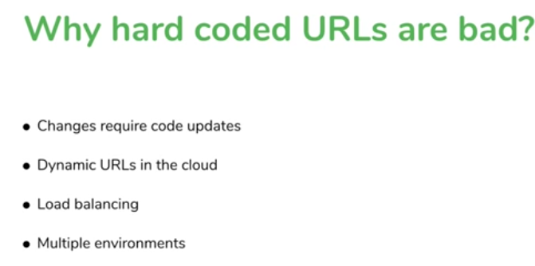

-Service Discovery is a pattern

When microservice is built we want them to talk to each other

- how do they how to talk how they find target

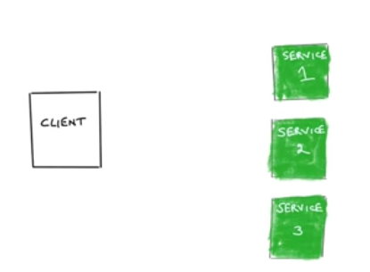

For Ex: we 1 Client Server in our case movie Catalog we have other service it need to consume

Min things make server discovery pattern

- we need register service some where should provide service layer ob abstraction

-Discvoer service will be incharge of what those service are for and knows where they are

Client calls discovery service ask I am looking fr give m url and calls that service

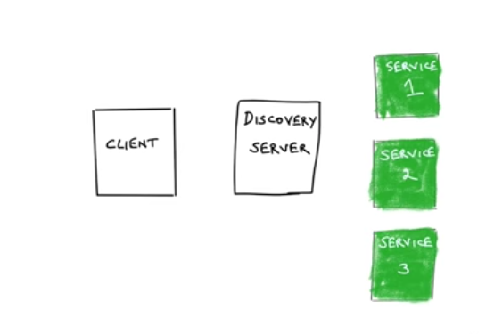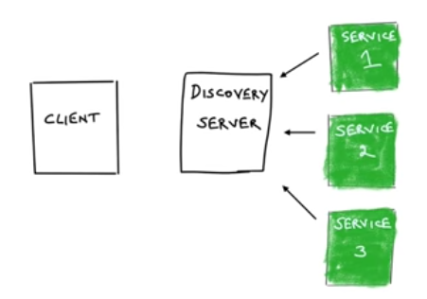

Each of the service which want to be discoverd register itself to Discovery server

- Once it is registerd to discovery server

- Client talk to discovery server and asks can I get service 2/1 please

- discovery server sure I can provide that where I find retrun url to it

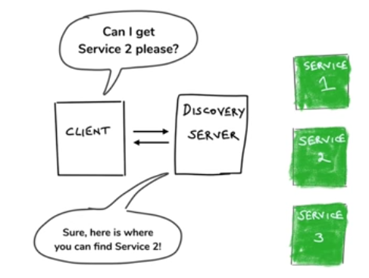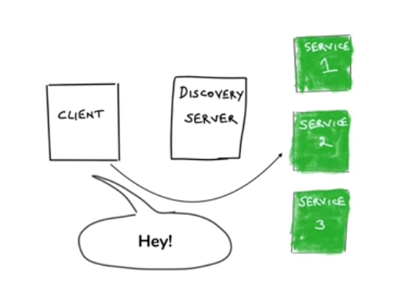

Then Clint once get URL calls to service 2 directly

- draw back is its little bit chatty rather making call directly and get data

- there is additional step 1 st hop then response then make making actual call

The above methods is called :> CLIENT SIDE SERVICE DISCOVERY bcz client do this

Alternative to this we have

SERVER SIDE SERVICE DISCOVERY

- here also service will register to Discovery server 1st

- but in nxt step client doesnt ask Discvoery server to give url

- instead it will say tell service 2 this msg

- don’t contact service directly calls discovery server(Technical its not discvoery any more like something on server which is in charge to passing right msg to server)

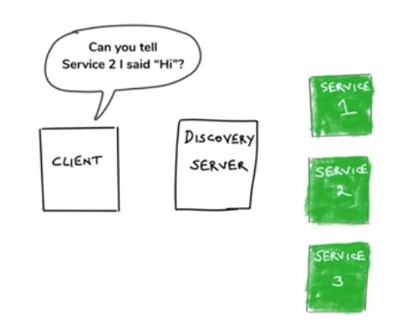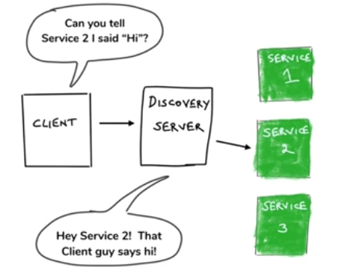

In this method no extra hobs direct contact

Spring Cloud uses Client Side Discovery

- When the application is built on Spring Boot and Spring Cloud if we want use service Discovery. library which facilates this resides in Client side

- Discovery server will be in different server but the work involved In calling those Discovery service reside in client side

Technology : EUREKA

-technology that implements discovery server that spring clouds uses that inegrates with EUREKA

- there lot of technologies EUREKA is one most commonly used

- NETFLIX OSS -Eureka is one of its project made open source

-netflix is the one of the microservice library provider which made it has open source that well work with Spring BOOT

EX: EUREKA,RIBBON,HYSTERIX,ZUUL

Spring Boot/Spring Cloud abstraction layer

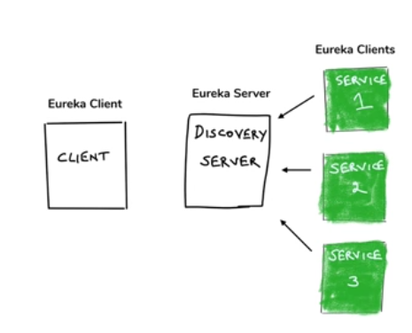

-Eureka server need to be created

-Eureka clients need to be registered with Eureka server

- Even the consuming also need to Eureka client

- Eurka client doing 2 things

1 its telling eurka server I am here let m know some body needs m.

2 Eurka client can also talk to server ask if he need somethings I need this service

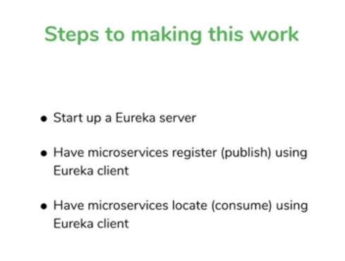

-Eureka Server is not like Tomcat server

- we need to create Spring boot Applciation to include Eureka server

- Go to inteializer in Dependcies add

Eureka server

One more dependcies Eureka discovery that the client spring boot comes with 2 dependecies

Based on project will add 2 dependencies

Workspace : movieserverdiscovery

@EnableEurekaSErver tells its EurekaServer

@SpringBootApplication

@EnableEurekaServer

public class MovieserverdiscoverApplication {

public static void main(String[] args) {

SpringApplication.run(MovieserverdiscoverApplication.class, args);

}

}

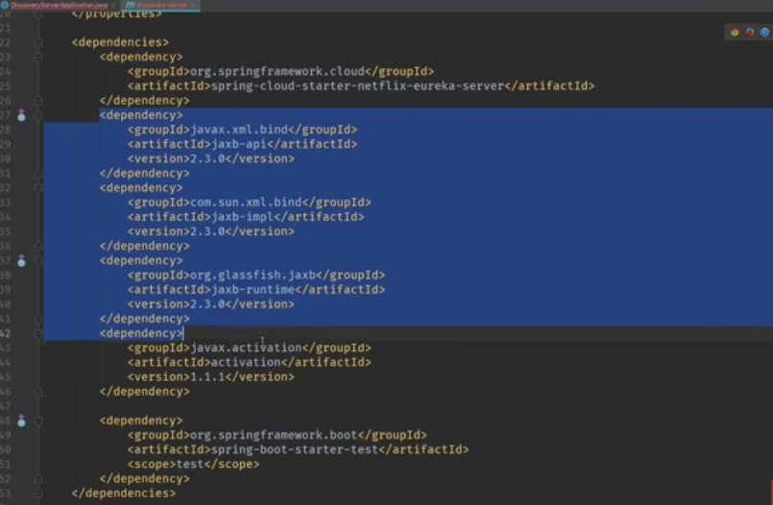

High lighted depedncies are not part of download this is need to added if java 11 being used bcz from java 9 javax error since it is removed from 9 but if its 8 no need to add it will work it is deprecated from java 9/10

- javax xml default part of jdk

- if want to perform java xml in futur version extranl we need to add it

Mention cloud version for the respective Spring cloud ypu want work with

<properties>

<java.version>1.8</java.version>

<spring-cloud.version>Hoxton.SR6</spring-cloud.version>

<!-- <spring-cloud.version>Greenwich.RELEASE</spring-cloud.version> -->

</properties>

It will be started has Eureka server

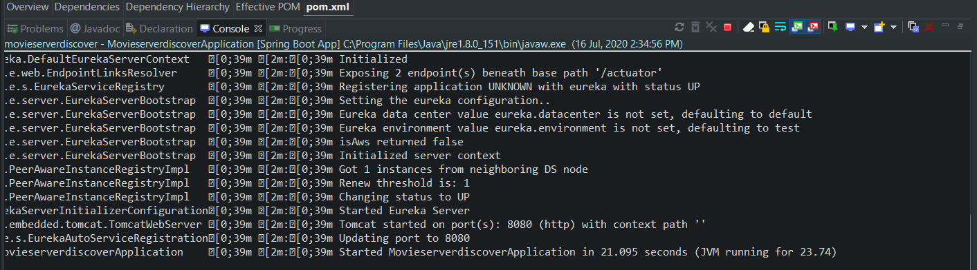

By default eurka server on port :8761

But here running on 8080

<http://localhost:8080/>

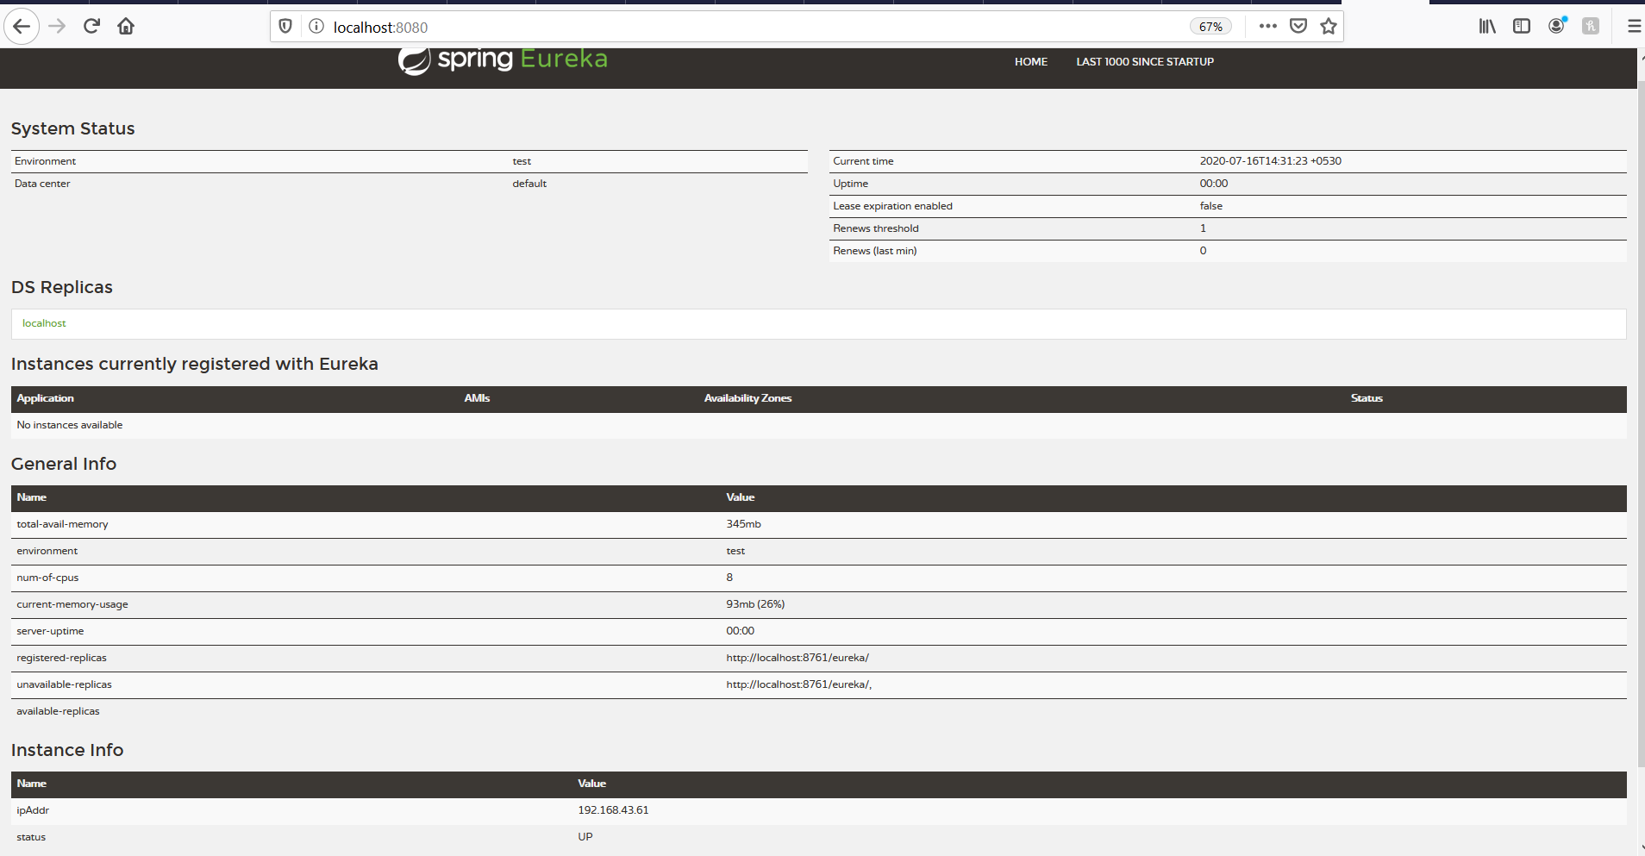

It will show type of environment server start and up time

- Instance menu shows eureka clients regisetred to it that is registered by the microservice blocks

- general info and metrics not only provide UI provide location information of UI

- Even with all config and depeddnecy we will get error while building Eureka server

Then add these in properties file

server.port=8761

eureka.client.register-with-eureka=false

eureka.client.fetch-registry=false

Aboove 2 propeties need to added in eurka server to make eureka server should not reg with itself

Every eureka server is also a eureka client

When it runs not only it provide registry is also tries to register with other eureka servers bcz not only we can have multiple instance of micro service we can havve multiple instance of eureka servers also and they can reg itself if one server fails another will connect

Now we need to add Eureka cleint Dependency in those 3 micro service ti register itself with Eureka server

<http://localhost:8761/>

Add eureka client dependecy in microservice project and provide spring cloud version to know its version type

- if our version in prperties it will be like global it will avoid setting version to all spring cloud realated dependencies

<properties>

<java.version>1.8</java.version>

<spring-cloud.version>Hoxton.SR6</spring-cloud.version>

</properties>

<dependency>

<groupId>org.springframework.cloud</groupId>

<artifactId>spring-cloud-starter-netflix-eureka-client</artifactId>

</dependency>

- will get improper build add these to complete it

<dependencyManagement>

<dependencies>

<dependency>

<groupId>org.springframework.cloud</groupId>

<artifactId>spring-cloud-dependencies</artifactId>

<version>${spring-cloud.version}</version>

<type>pom</type>

<scope>import</scope>

</dependency>

</dependencies>

</dependencyManagement>

Just strat server once adding these depednceies automatically it register with eureka server bcz same running in local system

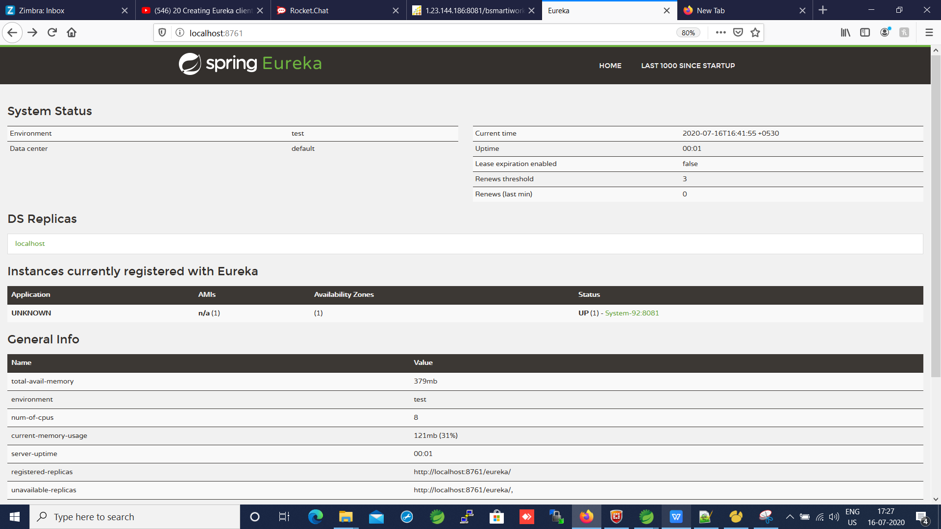

Shown in eureka server not changes any code just added eureka client dependency in class path and it reg itself

- reason is it showing unknown fr application name we need to set application name to micro service

To name application : spring.application.name=movie-catalog-service

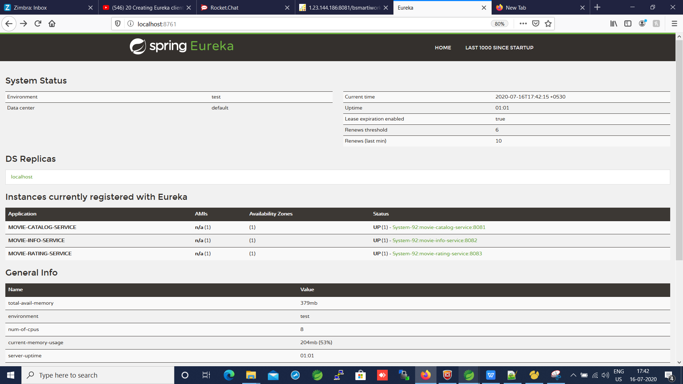

To know its a eureka client at Main class use @EnableEurekaClient to say its a eureka client but its not mandaatory in latest version

-hw the client find eureka server ? hw it know where to register

- here tried default port of eureka server so tries for that default port and reg

-but if its in diff system we have to that in property file we have to add certain config record and send it to where eureka server

-Reg now now where to consume it now movie-catalog-service is the consumer

- Another annotation when RestTemplate is been used we can say to RestTemplate to make an API call to service discovery get service location and make use of same RestTemplate to make another API call . Rest Tempalte has that ability hide that from us

- Tell RestTemplate I want to call Service Discovery everytime I will give u service name and u gone call service discovery every time

- same model we discussed service hide service discovery

For that use Annotation @LoadBalance on top of RestTemplate Bean

* @LoadBalanced : it does server discovery in a load balancing way

* we will not give acutal url give we will give hint to the url to find that in service discovery

Based on this hints RestTemplate will call the service using url’s

Instead of giving localhost:8083 it has no hints which service to call take this and ask eureka server whats localhost:8080 eurka say no bcz it knows only application name only name only we need to give has hint

-once all done we get one more issue java 8

# [Springboot error for Eureka with browsers showing xml instead of json](https://stackoverflow.com/questions/56839197/springboot-error-for-eureka-with-browsers-showing-xml-instead-of-json)

When I start this service and verify it in any browser: [http://localhost:8083/ratingsdata/users/sachin](http://localhost:8073/api/all/), I get JSON response displayed.

Now if I want to introduce my service to EUREKA service registry then I will need to do following changes.

As soon as I start my service then I start seeing it on server <http://localhost:8761/>

Now I again go to browser and try to check my microservice [http://localhost:8083/ratingsdata/users/sachin](http://localhost:8073/api/all/) What I see is XML and not JSON.

<List>

<item>

<movieId>1234</movieId>

<rating>5</rating>

</item>

<item>

<movieId>5678</movieId>

<rating>4</rating>

</item>

</List>

This result in come only in Browser not in postman postman getting default json only not xml changing in header we can decide the default value

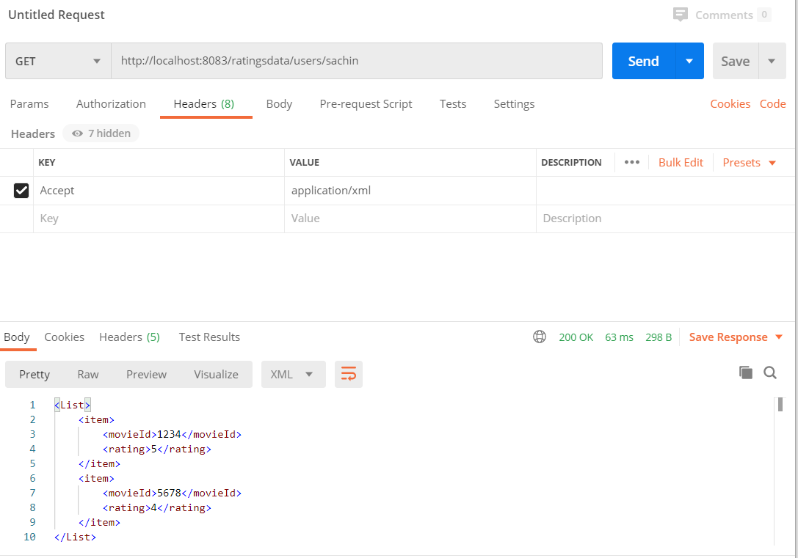

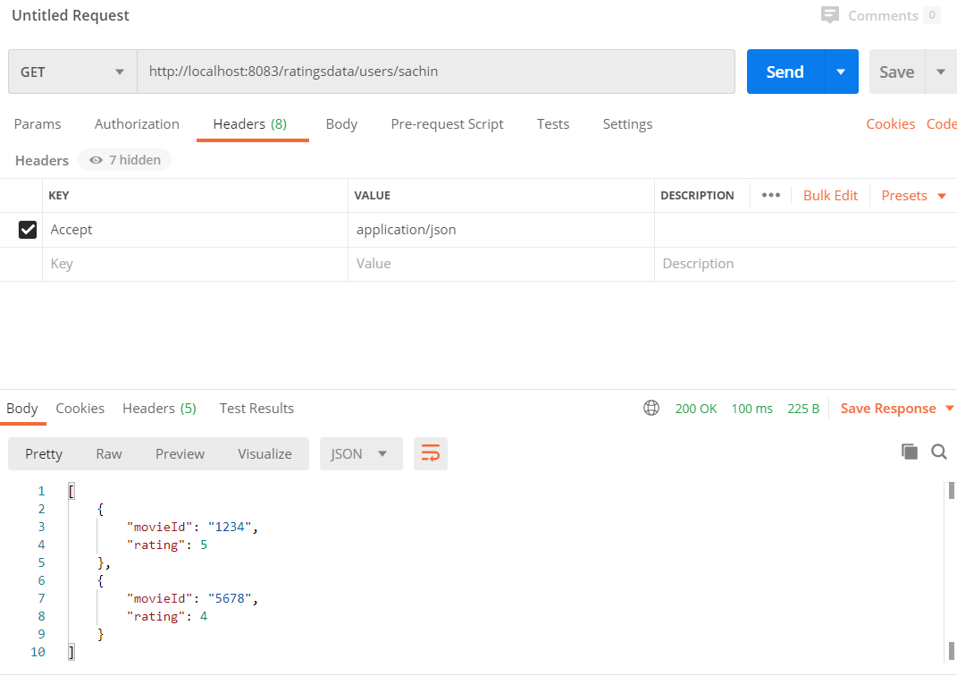

Or

Externally add these line if we want json value

@RequestMapping(value = "/ratingsdata", produces = { "application/json" })

Externally add these line if we want json/xml value in header we can send in req time wt we want

@RequestMapping(value = "/ratingsdata", produces = { "application/json", "application/xml" })

Externally add these line if we want xml value

@RequestMapping(value = "/ratingsdata", produces = { "application/xml" }

Below are used at microservices of client to register itself with a particualr eureka server

in different location rather then using same system def Externally add these line if we want json

eureka.client.register-with-eureka=true

eureka.client.fetch-registry=true

eureka.client.service.url=http://localhost:8761/eureka/

After eureka clients get service infromation by calling eureka server does it call eureka server for every subsequent call to the service?

- no not always there is a default cache wil be there

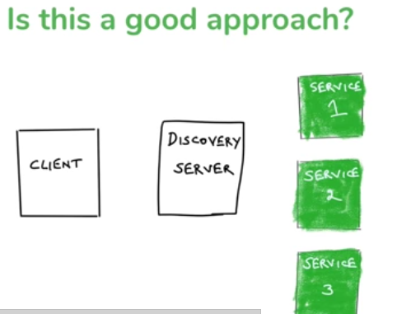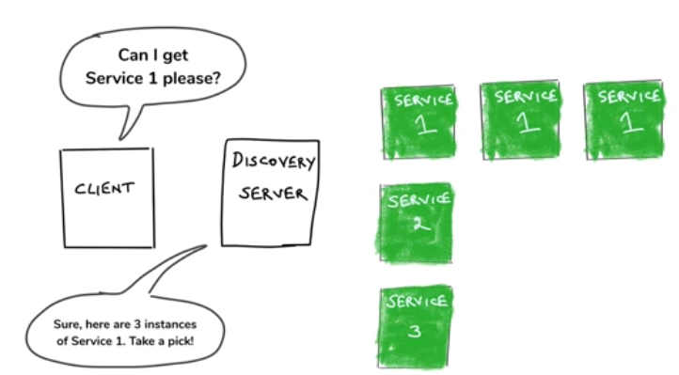

Y the annotaion Is@LoadBalanced it not only doing service discovery it also doing load balancing doing load balancing in client side

- I we have multiples servers in above client ask for Service1 but server discovery say we have 3 instance of service1 so client will do the load balance

There is way to run jar file by provideing diff port

Before tat add these in pom/xml to say what kind of exporting u need

<packaging>jar</packaging>

<groupId>io.boot.micro</groupId>

<artifactId>movieinfo</artifactId>

<version>0.0.1-SNAPSHOT</version>

<packaging>jar</packaging>

Run as Maven clean - > then Maven install to create respective jar or war file in target folder for that need to mention packaging in pom.xml

To excute Jar run this commend with and also mentiond diff port to strat using -Dserver=8084

With custom server port in app

java -Dserver.port=8084 -jar movieinfo-0.0.1-SNAPSHOT.jar

With def server port config in app

java -jar movieinfo-0.0.1-SNAPSHOT.jar

After this commend server will start in 8084 port and register to eureka clint itsellf now service 2 has 2 instance so load balanc will happen automatically

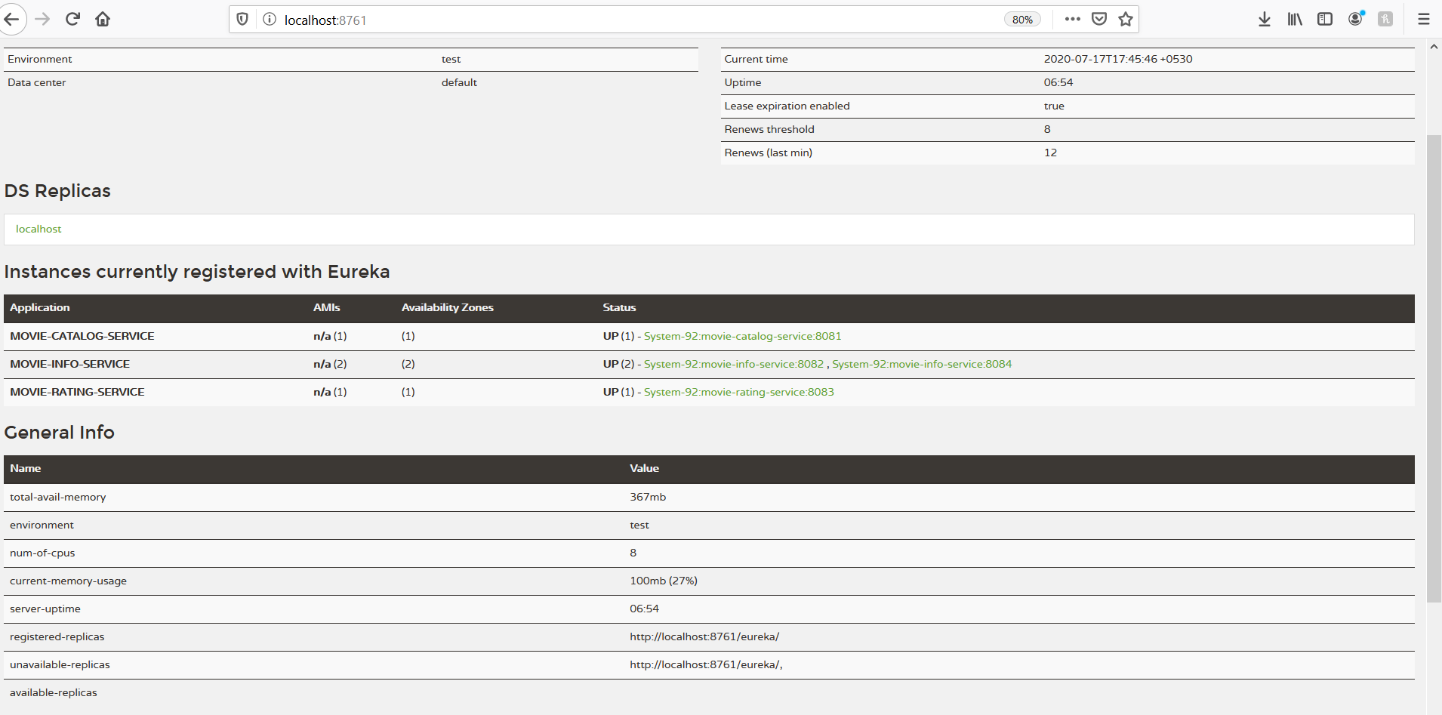

When we run jar we can -D and property name=value key ex: -Dserver.port=8084 its java feature not spring feature

Spring uses same config as java so it will override same

- we will get same data no change from which server it will take its upto that load balacne , client side load balance done

- Server names also we can store in properie files to make it dynamic when ever application name changed

- To Do more programmaticaly

Add these below line in consumption logic it will give an Interface

@Autowired

private DiscoveryClient discoveryCleint;

Interface will be having below method

List<ServiceInstance> getInstances(String serviceId);

To getinstance method we pass serviceId ex movie-info-service and we get list of instances

We get list of ServiceInstances

-discoveryClient.getInstance(“movie-info-service”) get details in list loop thorugh it for advance balance or condition

Recap:>

How Fault Tolerance Works

What happens if service goes down among 3

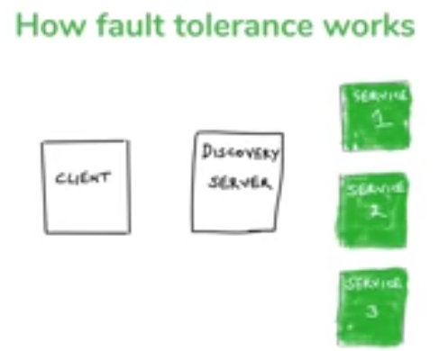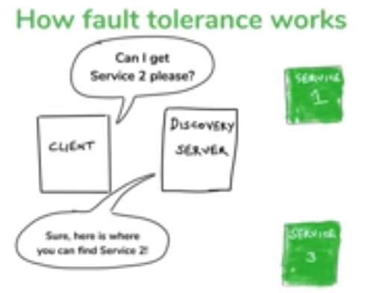

Now its not there how to make sure its down or up

Solution

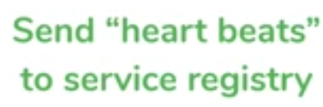

Whate eureka cleint does defult ping eureka server on regualr basis with heart beats

- if servers doesn find ping in some time tells it down and remove from registory , so its not one time discovery its a constant

- what If discovery servers goes down there caache come to play

